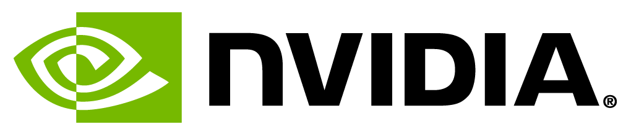 

# **GPU Self-Paced Programming Labs**

As part of the GPU Teaching Kit, you will have free access to [qwikLABS](http://nvidia.qwiklab.com), a supplemental teaching resource. QwikLAB is a live, hands-on, self-paced learning environment. Each lab includes a set of interactive instructions to walk students through a specific concept. As these labs are hosted in the cloud, a student only needs a web-browser and internet access.

**If you are interested in using these labs, please create an account at** [**nvidia.qwiklab.com**](http://nvidia.qwiklab.com/) **and send your qwikLAB account email address to** [**educators@nvidia.com**](mailto:educators@nvidia.com) **with the subject line “GPU Teaching Kit QwikLAB Access”. Instructions will then follow for giving access to your students.**

## **Lab Topics Include**

CUDA C/C++, Fortran, Python

OpenACC

Introduction to Deep Learning

Optimization and Debugging

Multiple-GPU programming

Libraries

And More!

To see a list of all available labs please go to [catalog](https://nvidia.qwiklab.com/lab_catalogue) and click on the Labs tab.